**NHS Digital – EPS data packs generator site**

This application allows the authorised user the ability to generate and load demographic data into the various Path To Live (PTL) environments in a quick and efficient manner.

Link: <http://tdp2lds.hscic.nhs.uk/pls/apex-prod/f?p=159:101:2219329220769606>:::::

**Login Details**

Username-ext_rama

Password-password

**Instructions for use**

Once logged in; user will see the dashboard with Demographics and Prescriptions menu options. These options can also be navigated to from the top right hand of the screen. The demographics and prescriptions menu options will allow you to generate the required number of patients with EPS data packs.

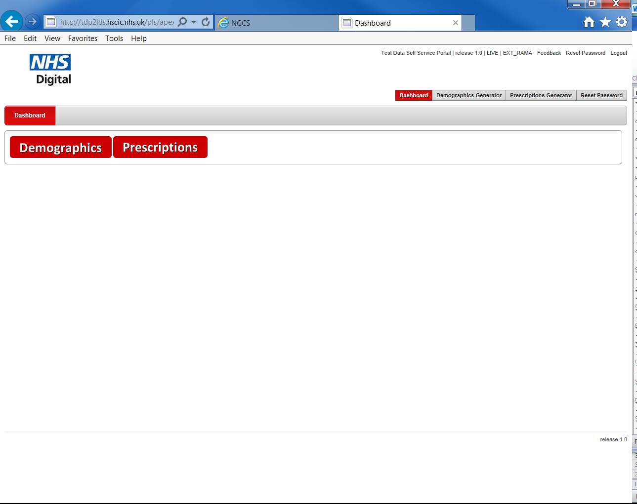

To generate the patients; follow these steps:

|  |  |  |
| --- | --- | --- |
| 1. Select a GP Practice from the drop-down list or leave it blank to use the default. 2. Select whether you want to generate a 'Predefined Template' or 'Define your own patients'. 3. If you have selected to generate a 'Predefined Template' then choose one of the available templates (a description of each pack can be viewed by selecting each one in turn). 4. If you selected to 'Define your own patients' then populate the volume, gender, DOB, DOD and sensitivity fields with your requirements. 5. Select one or more environments in to which you would like the patients loaded. Usually for testing; the packs are generated for the integration environment. 6. Click on the 'Generate & Load Patients' button to confirm your requirements and load the patient in to the selected environment(s). You will know that it is completed when the Completion Status area has a Status of 'COMPLETE'. 7. Once completed click on the 'My Demographic Packs' tab to view and download this and previous packs that you may have generated. The output is available in MS Excel format |  |  |
|  |  |  |  |

|  |  |
| --- | --- |
|  |  |

To generate the prescriptions; follow these steps:

1. Choose the Pack, Environment and Nominated Pharmacy from the lists available. The Test Date will default to 'today' and can be left unchanged unless you wish to age the data.   
2. Click the Generate Pack button.   
3. You will be taken to a Progress Report page which will keep you up to date on the progress. On completion your data has been generated and loaded in the selected environments.   
4. On completion click on Download Reference Pack and save this locally for your use.